I write this month with more good news and progress from the Nassington Energy and Thermal Project.
Thank you to Tom Conte: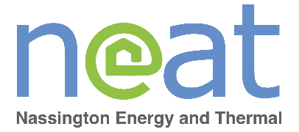
Let me start with a huge and heartfelt thank you to Tom Conte for his incredible graphic design skills and creativeness that he has used to produce our fabulous new logo, featured here. We think it looks fantastic and will help everyone to recognise the project as we move forward.
We got the grant!
We were successful in our grant application to the UK’s Community Energy Fund, with an award of £40k to explore the financial and technical feasibility of various heat and power options for the village. We have also tendered and selected a partner to work with us on this key phase and are in the process of running final diligence checks. The next phase of work will involve analysis of the energy demand profile of the village, as well as the potential of different solutions. It will involve more active communication and engagement to tell you more about the options and conclusions so please keep an eye out for more information here and on the noticeboards around Nassington to learn more.
Recap:
As a reminder and for anyone who missed previous articles in January and April, we have mobilised a project team of Nassington residents to explore cleaner, more financially predictable and secure options for our heat and power. The idea is to mobilise a collective response that includes and benefits everyone in the village regardless of income or house type, removing the barriers that prevent individual homes from making a change. This could include, and we will explore the feasibility of, a renewable power source for the village powering a community heating network, enabling us to remove and reduce our dependence on oil, gas and expensive unpredictable energy costs. The project is being managed as a Committee of the Parish Council.
This will be a long-term project for the long-term benefit of our community.
Learn more and get involved:
We are still very much open for new volunteers, so please don’t hesitate to be in touch if you would like to learn more.
To be successful, we will need a team effort and diverse skills and involvement. There are still lots of skills we need – from community engagement, communications, engaging with the local council and many more. Above all, we will need curiosity, passion and persistence, and the support and involvement of the whole village. So, whether you are an expert or novice, excited or sceptical, whether you have lots of time or very little, we would love to hear from you.
Contact us at:
- neatproject@mail.com
- Pamela Wall at 34 Church Street, 07747 690 607, pamela@re-leadership.com
- Any member of the Parish Council.

