assington Energy and Thermal (NEAT):

NEAT is a Committee of Nassington Parish Council which is run by volunteers who live in the village. Through the parish council, NEAT has applied for and been awarded a grant to carry out a feasibility study into options for community energy and heating for Nassington. The study has been undertaken by Locogen, a specialist consulting company, with the objective being to identify secure, clean, sustainable and financially predictable options for the future supply of heat and power to the village.

The last few months have been a busy time for the NEAT team. This period has coincided with increasing global uncertainty resulting from the disruptions to global trade following the introduction of trade tariffs by the US and the continuation of various armed conflicts around the World. These geo-political issues come at a time when climate change is increasing the likelihood of disruption and damage to critical infrastructure through extreme weather events. This all combines to create uncertainty over the cost, availability and reliability of traditional energy supplies. With so many factors beyond our control, this project seeks to harness the power of what we can achieve ourselves by working together to improve our options and create energy resilience.

Against this background, the NEAT team has focussed on progressing Locogen’s feasibility study for community power and heating options for Nassington. Locogen’s report will investigate a range of both new and well-established methods for generating heat and power and will make recommendations for establishing a viable and sustainable network for Nassington based on anticipated future demands and the specific characteristics of the land around the village.

The team’s thoughts are now turning to sharing the findings of Locogen’s report with the local community and thinking through the next steps in the development of the scheme. The team has been considering how to deliver practical support to inhabitants of the village through community workshops aimed at sharing knowledge and information on issues such as improving home insulation and the adoption of new (and greener) technologies for home heating and power.

The following activities are planned for the Spring and early Summer:

Activity | Location | Date
Finalisation of Locogen’s report | NEAT team meeting | 11th April
NEAT drop-in at Biscuit Tin to share information. | Village Hall | 28th April
Presentation of Locogen’s report | Village Hall (Evening Event) | 15th May
Presentation of Locogen’s report | Village Hall (Morning Drop-in) | 16th May

Please save the date(s) and join us at the Biscuit Tin or for the presentation of Locogen’s findings at the Village Hall events and to help shape the future of Nassington’s energy.
Future activities anticipated include a draft-busting workshop (see below), the establishment of a support group for heat pump installation and operation and activities such as a climate change talk. Please keep an eye out for further information about these and other activities.

NEAT HEAT (Home Efficiency Awareness Team)

One of the key short-term objectives of the project is to help residents be better informed about heat loss and how to improve the efficiency of homes. This will include training, home visits, information sharing and tools such as a ‘thermal imaging camera’, to identify areas to target to reduce heat loss. The team is also proposing to set up a heat pump installation and operation support group for people to share experiences and helpful tips. Do get in touch if you would like to volunteer to assist or participate in any of these initiatives.

One of the inspirations for the NEAT team has been the fact that many other communities and villages around the country are also trying to develop community power and heating schemes. Many individuals from these groups have provided us with support and helpful advice both freely and cheerfully.

Finally, a reminder that this project is for the benefit of all residents and businesses in Nassington. So please engage with us and share your comments and your ideas. We are keen to reach and hear from everyone in the village. If you’d like us to come and speak to you, individually or within a group, please let us know. We are always keen for new volunteers to join the NEAT team; if you are interested in getting involved, please do get in touch with us.

Contact us at:

- neatproject@mail.com
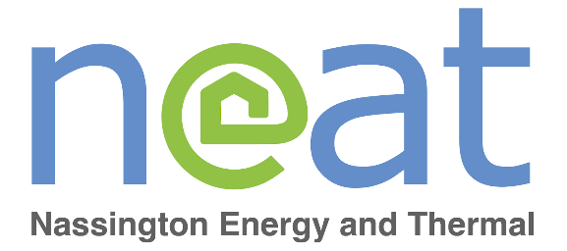

Or contact the Parish Council.



